**Black Scholes Calculator Add-in:**

1. Save “Black Scholes Calculator.xlam” to your desktop (note – the instructions assume you saved the file to your desktop but you can save it anywhere following the same approach)
2. Open a new excel file and save as “Test.xlsm”

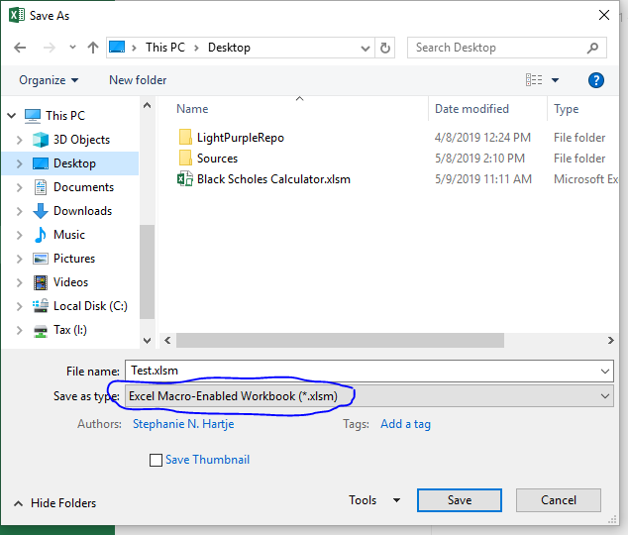

1. In Test, go to the Developer tab and click Excel Add-ins on the tool bar

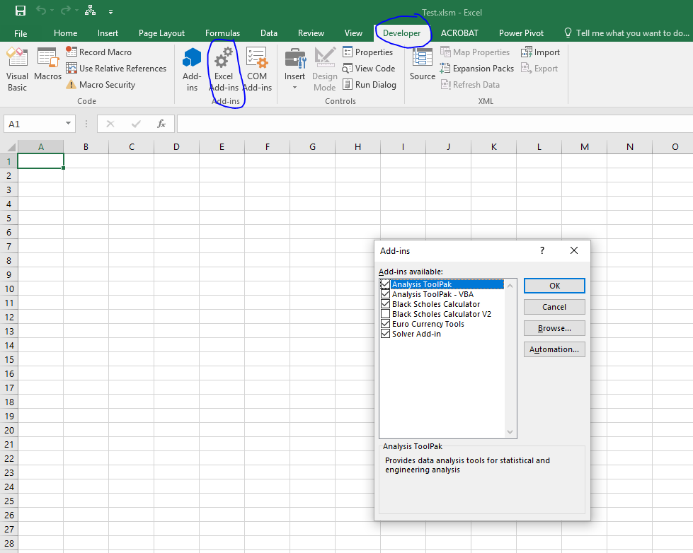

1. In the Add-Ins window, click Browse. In the Browse window, click desktop and then select the file you saved in Step 1 “Black Scholes Calculator.xlam” and click OK.

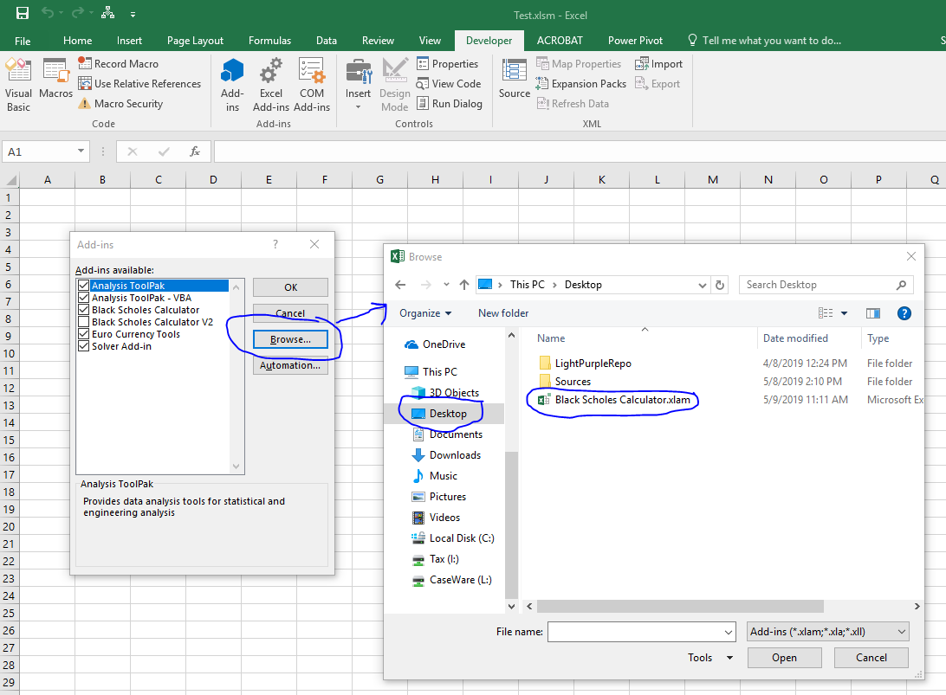

1. You should now see “Black Scholes Calculator” in your Add-in window (Note – you could already see it in the screen shots because I had already installed it when I made the instructions). Click the box next to it and hit OK.

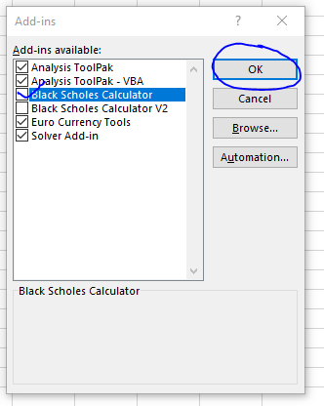

1. Right click somewhere on the grey portion of the tool bar and choose “Customize Quick Access Toolbar”. This will open a new “Excel Options” window.

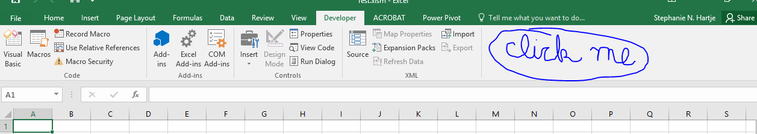

1. Choose “Macros” from the drop down list. Then select “displayUserForm”, click “Add>>” and click OK.

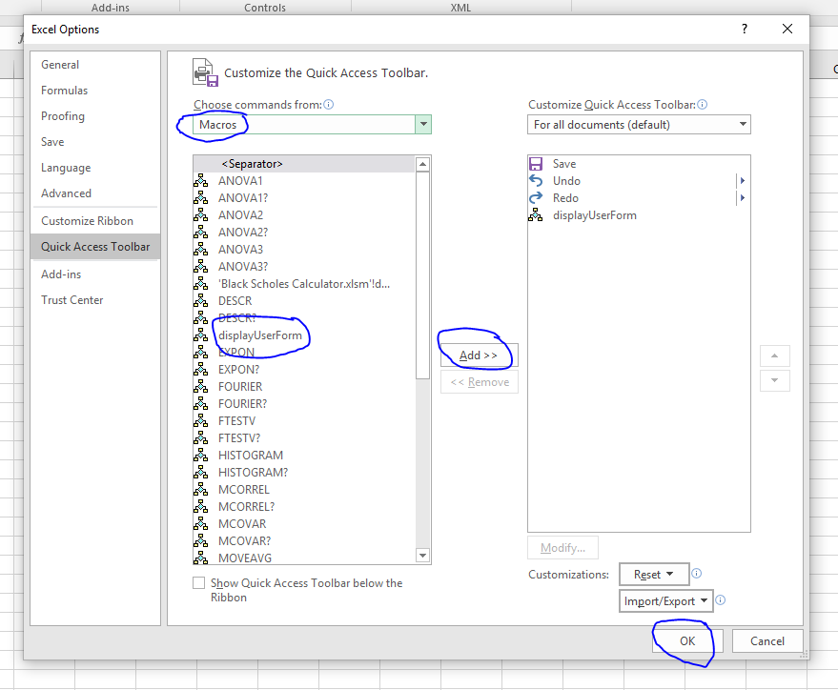

1. You should now see a small icon like a legal entity chart on the green part of the tool bar

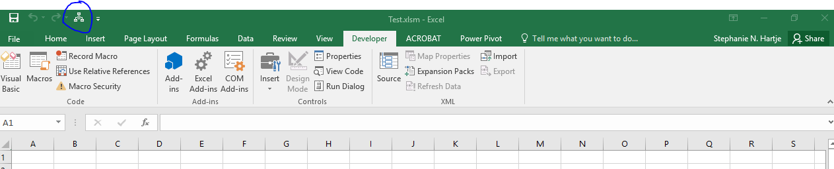

1. Click the icon to open the Black Scholes Calculator

